**大纲**

# **Executive Summary**

## **Vision**

## **Platform**

## **Why do we make 2 games**

# **2D Game**

## **Introduction**

### Play to Earn -> Play for Fun

### Ecosystem

## **In-game Assets**

### NFT

### Marketplace

### Connector

## **Social Profile Interaction**

# **3D Game （重点讲）**

## **Introduction**

### 5W1H

### Metagame vs. Metaverse

## **Projection**

## **Immigration**

## **PGC & UGC**

### Public Experience

### User-Created Content

· Instances

· Reward Model

· Community & DAO

· Tooling

## **VR**

# **Tokenomics**

## **Allocation & Unlock Schedule**

## **Governance**

## **Staking**

## **Payment**

# **Technology**

# **Roadmap**

| **[PROJECT NAME]** | **Retro World** |
| --- | --- |
| **[TOKEN NAME]** | **Ruby** |
|  |  |
|  |  |

# 

# 

# 

v0.1, December 2021 LTD corporation

### White Paper

White Paper Draft 1 原稿

###### AUTHOR: Di



##### Disclaimer

SOME LEGAL TEXT



3 white paper



Contents



Abstract 5

Executive Summary 6

Game-Chain Connector (SDK) 9

Social Profile Showcase 10

AI-Powered Style Transfer 12

General NFT 13

Cross-chain NFT Marketplace 14

Team 33

Sales Team 34

Design Team 35

Technical Team 36

Advisors 37

References 39

INTRODUCTION

## Abstract

Technology frequently produces surprises that nobody predicts. In late 2021, both the terms “Metaverse” and “Web 3.0” reached maximum public popularity according to Google Trends. We also observed tech giants as well as startups aggressively revealed plans about constructing their interpretation of Metaverse/Web

3.0 apps, leaving many fundamental questions to the public:

#### *“How can I get involved?”* “Which metaverse should I join?” “Do I own the content I create?”

We dislike the uncertainty as much as you do. Therefore, our answers are:

#### *“...by creating your own version of* metaverse”

#### *“...any, or, all of them”*

#### *“...absolutely Yes!”*





## Executive Summary

三驾马车 content service asset

##### Overview

Retro World is a sophisticated platform that bridges not only traditional video games and the blockchain world but also provides solutions to connect different metaverses. It includes:

* An SDK(Software Development Kit) for game developers to easily interact with blockchain applications
* A social profile showcase, where users can customize their public profile pages
* An AI-powered style transfer toolkit, to convert any image’s style into our style
* A general-purpose non-fungible tokens(NFT) mechanic that is accepted in all participating games
* A cross-chain NFT marketplace where players can buy and sell NFTs on any preferred public chains
* A utility token, [TOKEN NAME], to fuel and govern the entire ecosystem over DAO (Decentralized Autonomous Organization)
* A native pixel roguelike RPG (Role-playing Game) which acts as the portal to [Proj- ect Name] and introduces the ecosystem to a broader range of audience
* A native voxel open-world metagame that accepts immigrants from any other metaverses

Our vision is to offer a platform for once-isolated metaverses where people can easily conduct economic cooperation that allow assets/value to flow without borders.

Currently, players are naturally separated by individual games, but each player usually plays multiple games. For one specific game, the centralized ownership and the exclusive value of the user-generated content can create barriers that stop assets from being traded to other games, and therefore can induce significant costs for players who want to try different games. For example, the ownership of a rare weapon skin from CS: GO is governed





by Steam, there is no way to directly swap it for an equally rare wearable in Dota 2: even if both games are solely operated by Steam. Players have to trade the item they own on Steam Community Market for fiat money first and then buy new items in other games with fiat. In such cases, they have to pay premium fees as well as the opportunity cost of the future value of the item they sell.

Meanwhile, game developers may find blockchain technology very helpful regarding the overall user experience and can attract more players, but it is too difficult or expensive for small-sized developer teams to integrate with blockchains because, in the domain of cryptography, there is usually only one way to do things right but infinite ways to make them wrong.

We are aiming to overcome these limitations by employing the most cutting-edge blockchain technology. We are introducing a revolutionary designed general-purpose NFT that can be converted to or from any valuable in-game content by staking.

Since 2020, we have observed many entities are entering the booming metaverse sector, while they have been trying to create their very own virtual world.(but centralized , 1. gala-他们不够DAO, 没有新机制，其实是web2.0+defi内核 2. cryptopunks （艺术品品类，为什么艺术品现在没办法被所有人认同，因为没有一个共识的world 来display 包括用虚拟世界承载价值，也没有落实到最终以一个人的视角的存在，we offer social links ） 3. facebook（way too centralized +官僚主义+寡头垄断，giants 在web3.0的构建是注定失败的） We decided to make an open-world game in Phase 2, （world，multiuniverse，中心点 O-O-O，nebula， MOD 1. external assets display ---- By POCC 2. creator ---by pocc—--星球---etc. DJ festival/ music NFT++++ 3. 2D to 3D game, we will create a paradigm called projection here 2D,我们会在IDO 之后，1个月到两个月开始做2D to 3D 的demo，2D to 3D game 我们都会开发一个SDK来support routine 宣传片：一把剑，然后一阵闪光，3D世界里出现我的形象拿着剑。+我们的自营体系也就说引入Ruby生态是基于steam类似钱包和自发行游戏，有可能的话我们自己先在我们的3Dgame 做一个轻roguelike ，需要它来生成资产NFT）where players can carry over their profile and do anything they want. For example, The Meebits (created by the CryptoPunks team) NFT owners could bind their wallets to import the unique character they own, with our state-of-the-art style transfer tool, they can easily immigrate to our open-world with stylized character skin and blend into the ever-growing new world. Users may also upload any picture to create unique in-game assets, they would look equally awesome and consistent with the existing environment.

我们不需要原画，但是需要一个整体的Vision ，包括UI，还有固定的几个故事角色，像MC里的steve。网页上，包括video就是他们出来。（先找一些冷门图，没啥IP的）

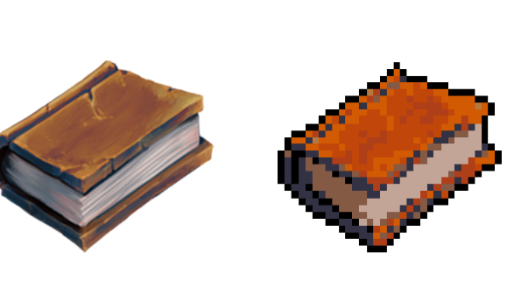

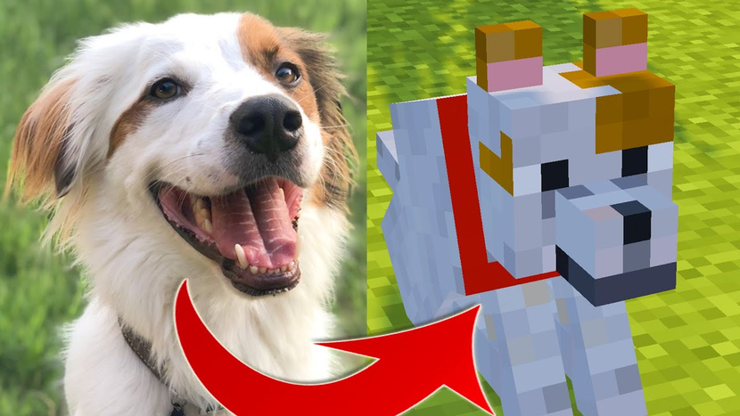

一个2D 图---------------> 3D 图(发美图群，然后一个示意图）

To achieve a smooth cold start, we also plan to release our very first game in Phase 1 to demonstrate how the entire system works. We believe it is the most intuitive way to introduce the new era of GameFi to the world.



The Platform





## Game-Chain Connector (SDK)

With various components mentioned above, our platform is responsible to maintain the interconnectivity among them. Viewing the platform as a whole, both content creators and consumers may find all tools they need to create or enjoy the next-level gaming experience.

##### Game-Chain Connector (SDK)

We have discovered that the territory of the crypto world and traditional game industry usually does not overlap. Existing tools focus too much on the Play to Earn (P2E) model, unlike them, we hand the decision-making power to users themselves. While blockchain gurus and game developers continue delivering innovation to the world, we decided to offer a bridge that connects both sides: our game-chain connector.

Game-Chain Connector is essentially an SDK (software development kit) targeting game developers. It provides an all-in-one solution and easy-to-use interface that allows any game to interact with popular blockchains.

Major functionalities include:

* Connection to popular crypto wallets
* Query on-chain data
* Managing the mapping between in-game items and NFT
* Bind existing item to NFT or mint and publish any in-game item as NFT (NFT-ize)
* Generate in-game items based on the property of NFT (de-NFT-ize)
* Maintain correct ownership of both NFT and in-game item
* Monitoring designated NFTs on various public chains
* One-click connectivity to NFT marketplace

We will provide the SDK as well as demos in many popular programming languages to cover most of the frameworks that developers favor. Developers may choose any subset of the features they want, with maximum flexibility.





## Social Profile Showcase

图=>

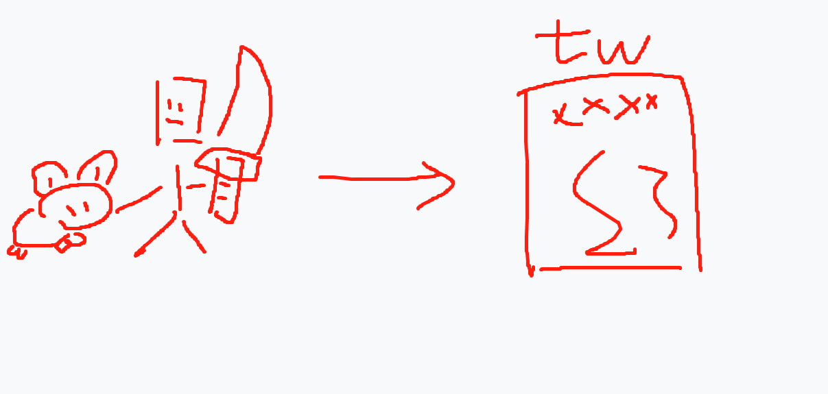

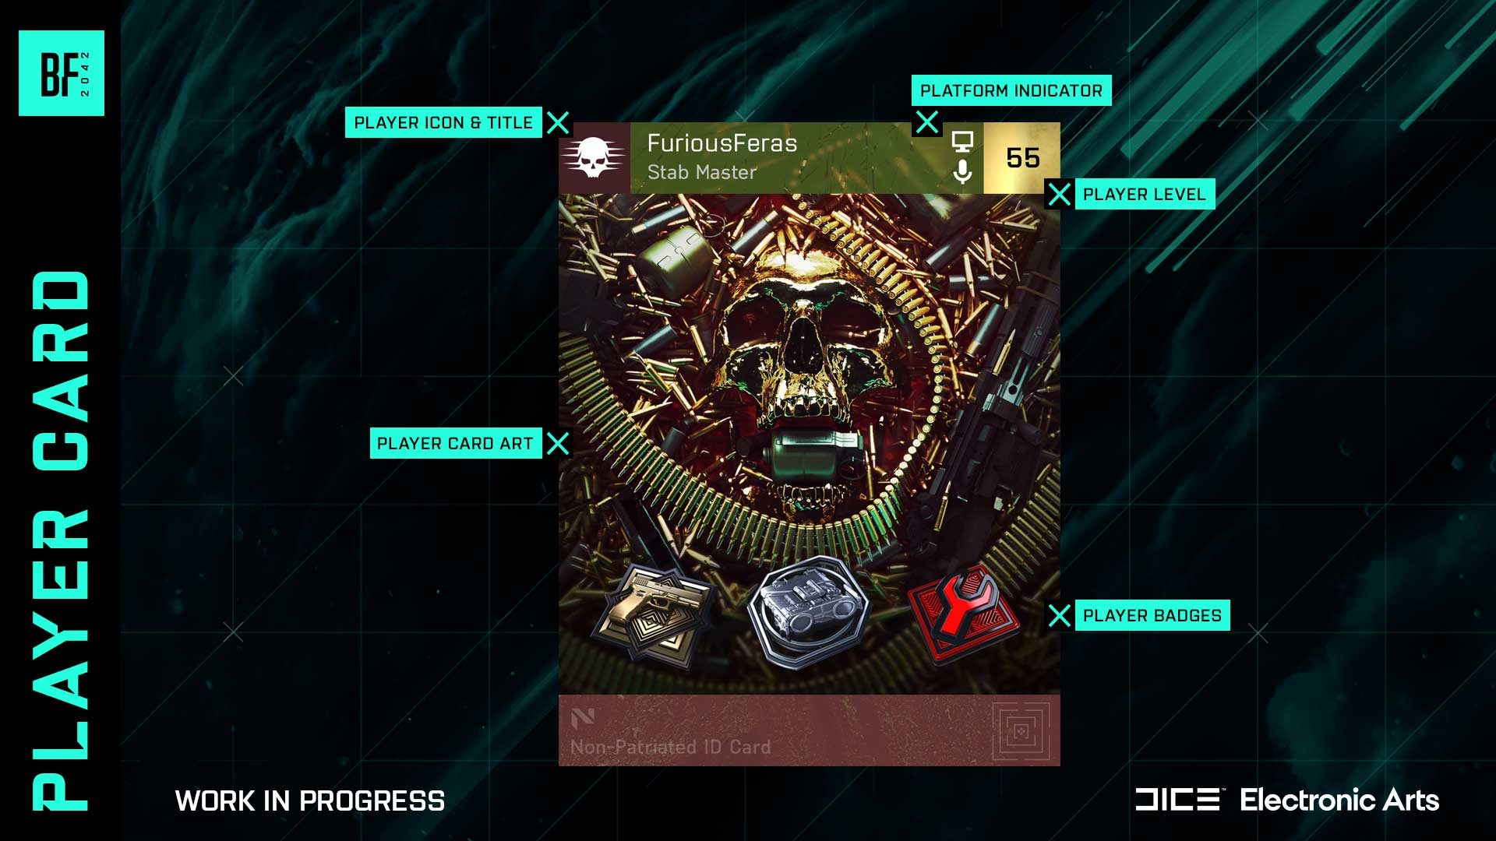

生成new NFT，这张NFT，以后变成 ID CARD 强调一下 ID CARD

ID CARD之后会跟我们的主营游戏里的道具稀有度和主世界projection contribution结合，CARD会成为节点价值的一部分，可交易 可转让

We understand that social features are crucial to enhance user engagement. They are in- teractive elements that resemble social media and form the in-game community that can be presented in various ways.

Each registered user will be given a permanent link to their public profile page. On the page, they have the capability to show off their recent in-game activities, progress, achievements, and collections they own.

One key social feature the social profile page offers is the personalized portrait.

A popular NFT project: CryptoPunks, has demonstrated that even the simplest elements (24 x 24 pixel portrait) can become a trending phenomenon. However, like other NFT collections, one of the most significant cons is that people cannot build an intuitive connection from the NFT digital art to an actual person. Considering Twitter, for example, users’ avatars always come with user names. One can easily build a portrait that represents himself.

With our effort reinventing the idea of NFT portrait, users can be more creative on a larger pixel space. Additionally, their usernames can also be included. Such portraits are more like a mini personal profile, or “business cards” that can be used everywhere.

Users with accounts on our platform may create customized portraits from scratch. Start- ing from picking the rendering style, users may select a wide range of customizable elements to assemble their unique portraits. Importing in-game assets and displaying them is also possible. Besides the free-for-all parts, certain visual elements are rarer and can only be obtained from in-game events or the marketplace.





The profile showcase also supports add-ons. A couple of add-on slots are reserved so that users could import their equipment images or pet images from the game. With infinite customization possibilities, each profile is unique.

We expect the social portrait to act as a social identity, thus even NFT portraits are solely owned by users, we do not encourage trading them as they carry the original owner’s mark. Additionally, although the NFT cannot be altered once minted, it contains a URL in its metadata to the original owner’s profile page, which can be updated frequently.





## PROJECTOR 1.2.3 one of the FUNCTIONs AI-Powered Style Transfer

（Projector）

We have incorporated a reputable design team and deep learning experts to build our one-of-a-kind style transfer tool. It is able to convert any image and make it look like a first citizen in our ecosystem, without losing its original characteristics.

This powerful tool is capable of filling the natural gap between different contexts. For ex-ample, it might be awkward for a pixel character to see an item in a realistic style. With our style transfer, it will be processed and appear with the same style.

This tool is publicly available for users to create their portraits, and is internally used to handle NFT minting, cross-game asset change, and immigration.





## General NFT 这部分不是重点

只讲痛点，我们是他们GOD来save your ass

Currently, most of the crypto games that integrate with NFT have a vital limitation: the value of NFTs is restricted to one specific game, and such NFTs only carry game-specific information that is hard for first-time players to understand. Therefore, we introduced a higher level of abstraction of NFT assets: one kind of NFT that is accepted in all games.

Imagine one scenario: Players invested a large amount of time and effort and obtained a rare NFT in game A. Then they are attracted by another crypto-enabled game B and decide to play game B instead; an optimal option would be to sell the rare NFT, by doing this, those players no longer possess advantages in Game A and have to make a fresh start in Game B.

Our general NFT solves this problem. For all games that participate in our ecosystem, the rareness of certain NFT is recognized across the spectrum. We plan to support a bi-direc- tional conversion from general NFT and game-specific NFT. This implies players’ invest- ments are secured in the entire ecosystem, and with the increasing number of games that join, they can expect a significant increase in the value of their NFTs. General NFT own- ers could easily stake their NFTs for game-specific NFTs, just like we usually see in other games, then stake it for in-game privileges based on their rareness.

Note that the conversion process is always bi-directional. Powered by our SDK, the conver- sion rates are highly customizable and can be dynamic. Thanks to sophisticated design as well as careful testing, we ensure such conversion is secured and a one-to-one mapping is always guaranteed, in other words, although NFTs are interconvertible, at any moment, there is only one mapping from NFT to corresponding in-game content.





## Cross-chain NFT Marketplace

我们的自营业务线

**we create game, while empowering the creators to create their own world. We use the projector and POCC to link the new world with out “retro world”--->做一个nebula**

**1.create—> roguelike-> 相当程度的randomness，收益分享给玩家，我们只收手续费，让他们collecting（直接脑子里脑补steam marketplace来写）**

**2.empower→ PROJECTOR WITH POCC protocol→ 分标题标语：WE believe creator content will be the coral/oil of web3.0**

**POCC→ PROOF OF CREATOR CONTENT**

**最后写，带一下这个内容 intergrate：**

**MATH(algebra**

**每个玩家收益：**

**1.creator 的DAO大型提案，like contract 承包商拿ruby reward（量少，类似staking）**

**2.自己project，也就是说random guy projects his assets, we give him ruby.reward （要给一个math 不会kill our eco，ETH直接增发给，我们走销毁并且给的话就是先吃螃蟹拿的多）**

**3. 全程 DAO 协会证明（提案，不需要具体）  
4.MOD开发者（大量的奖励，并且MOD开发者可以提出提案给社区让他们来填充project 的内容分享ruby，参与这个提案的creator需要质押ruby）**

1.

2.

3.

We understand the current NFT market is dominated by ETH-based smart contracts, but its high gas fee is stopping regular users from trading NFTs. Also, while other public chains have the same capability of distributing NFT, cross-chain transactions and cross-chain swaps are still loaded with trivial details and are expensive.

To address such segmentation between chains and to allow crypto assets to become in- teroperable, we introduce our cross-chain NFT marketplace. Powered by [Cross-chain tech], it is able to penetrate all potential user bases. Sellers and buyers could select what- ever target chain (including Layer 2) they prefer (eg. Ethereum, Binance Smart Chain, Car- dano, and Polygon, etc.) to trade NFTs.

We believe the more accessible to NFTs, the higher the chance of capturing additional us- ers and network value.



[PIXEL GAME NAME]





##### Introduction

[PIXEL GAME NAME] is a multiplayer rouge-like online game, where players can explore endless dungeons, slay monsters, and collect & trade billions of unique items. Being the first citizen of [Project Name], [PIXEL GAME NAME] is inspired by many popular rogue-like games, like Risk of Rain, Street of Rouge, etc, and it is created by experienced teams to guarantee its quality. The game seamlessly combines the best of two once isolated worlds: a joyful and exciting narrative for most demanding players as well as a carefully designed ecosystem in which players can convert their progress to tradable NFTs.

Being our first and native game, [PIXEL GAME NAME] is the portal to our ecosystem. During its development, we put gameplay as our highest priority, ensuring its uniqueness and quality. We have divined ways to emphasize the challenge and randomization that makes

roguelikes compelling while simultaneously making them more approachable, less intimi- dating. At first glance, [PIXEL GAME NAME] offers nothing but variety, challenges, and joy- ful adventure.

[Talk about competitors]

[Narrative design]

Unlike other crypto games that emphasize investment and return, we encourage regular players who have never heard about crypto to explore the blockchain universe while enjoy- ing the game. With a carefully designed economic system, [PIXEL GAME NAME] leverages [TOKEN NAME] which enhances the in-game experience. [More details about it]





##### Social Profile Interaction

Any NFT item players own in the game can be shown on their profile page. Players have the freedom to choose whatever NFT they would like to show. NFT display is not limited to those minted within our ecosystem, users are able to bind multiple public chains then perform mix-and-match on their profile page.

Moreover, [PIXEL GAME NAME] is highly integrated with Social Profile Showcase, which means many in-game assets, stats, activities can by synced to owner’s profile.

##### In-game Assets

During the gaming process, players have chances to complete various adventures and quests. Certain special items can be randomly dropped as rewards. Again we hand the power of determination to players: whether they want to trade it for other items or crypto, or keep it to show off on their profile.

##### Portability

We aim to take advantage of this game to demonstrate how seamlessly it can be to im- migrate to our open-world game. Therefore, upon the release of the open-world game in Phase 2, a one-click immigration option would be made available for all [PIXEL GAME NAME] players, players can carry over the progress as well as assets and then explore the new world with characters they are already familiar with.



[VOXEL GAME

NAME]





##### Tooling

We will release a set of tools for content creators to create their own instances (UGC). Tools under development consist of:

| Tool | Function | Cusomizables |
| --- | --- | --- |
| Map Editor | Create maps of any size | Terrain, building, weather, obstacles/  paths, etc. |
| Object Edi- tor | Create unique items within the  instance  Create characters, NPCs, mon-  sters, and their AI Create spells/magics | Appearance, interactive logic, stats,  drops, etc. |
| Rule Editor | Override the default game behaviors: listen to in-game events, query blockchain infor- mation, deploy custom scripts | Physical rules (eg. gravity) Actions allowed (eg. disallow PvP) Events (eg. random thunderstrike) Game flow (eg. victory condition) |

Thanks to [VOXEL GAME NAME] ‘s professional development team, it is flexible enough for most types of games and ways of playing to be ported in.

It is worthwhile to mention the support of custom scripts. Creators with programming skills could benefit from the extra flexibility it brings and bring their own innovations to the next level.





##### Introduction

Being a free-to-play, open-world game, [VOXEL GAME NAME] does not define a clear pur- pose by design. In fact, [VOXEL GAME NAME] is only a playground, players have the ulti- mate power to determine what they want to do. Notably, greater power of how the world works is handed to content creators and the community as well.

##### Basics

First-time players may find the [VOXEL GAME NAME] looks like Minecraft: everything is made of blocks. And we believe it is the best part of Minecraft: building things made easy.

A massive map is created as the base reality for everyone. It is the world every player lives in (as a symbol of existence), and also the map new players land on. There are also many instances, or “sub-world”, attached to it.

The entire world is made of 2 major parts: PGC (Professionally Generated Content) and UGC (User-generated Content).

|  | Maps | Rules | Narrative |
| --- | --- | --- | --- |
| PGC | Created by us  Everyone can join | set by us (eg. event map may  disable PvP) | composed by us |
| UGC | Created by users  Only invitees can join | set by users | composed by users |

POCC 和我们的new web3.0 projection . world generator





##### Instances (Base and Alternate Reality)

In our multiverse model, the reality consist 2 parts: one base reality, which is the single source or truth and is the place where everyone lives in; and infinite alternate realities.

Here, we adopt the concept of “instance” from the gaming industry: an instance is a copy of the base reality but things work differently there. In [VOXEL GAME NAME], an instance is equal to an alternate reality.

There are 2 types of instances: public and private.

Public instances are created and maintained by us, serving as the shared place that every- one can join and explore. Its resources are available to everyone.

For example

* a “City Hall” map is for common gatherings
* a “Concert” map is for special online events
* a “Battleground” map is for PvP activities

During the game operation, we would regularly extend the base map and release sophis- ticated pre-built maps with different narratives in order to introduce more possibilities to players.

Private instances are created and maintained by players. Players act as “The Creator”, with privileges like building landscapes and creatures, altering the rules, adding narratives, NPCs, monsters, and quests, etc.

Each player is allowed to create one home instance. Just like the game Animal Crossing, players build their houses and decorations. Visiting others’ homes is only allowed with the owner’s invitation.

However, private instances are mainly designed for content creators to build a “sub-world” or “sub-game”. Here are 2 example scenarios:





##### Scenario A

**Middle-earth adventure**

| Type | Single Player |
| --- | --- |
| Narrative | The player plays as a member of The Fellowship of the Ring, they are responsible for safely delivering the One Ring to Mount Doom and destroying it |
| Maps | Shire, Misty Mountains, Rohan, Gondor, Mordor, etc. |
| Content | The player needs to complete a series of quests, defeat monsters, slay the dragon, collect gold and equipment, to finally complete this instance |

##### Scenario B

**3 v 3 MOBA (multiplayer online battle arena)**

| Type | Multiple Player |
| --- | --- |
| Narrative | Destroy the enemy team’s Nexus to win |
| Maps | arena rift |
| Content | The player needs to compete with the other team to gain re- sources, like Dota 2 or League of Legends |





Once a content creator completes creating the instance, [VOXEL GAME NAME] will assign an “experience code” to it, so it can be shared with the community and everyone could join and play. The creator can also choose how they can gain profit from their content:

| Free to play | Completely free of charge |
| --- | --- |
| One time charge | Requires a ticket (can be an NFT) to enter |
| Microtransaction | Free to play, but players can spend [TOKEN NAME] to purchase buff or bonus to gain  advantages |

We will also hold content contests with the community and set up a pool of rewards.

##### Projection

We define [VOXEL GAME NAME] as a “Metagame” because it exceeds the narrow sense of how games look like, it does not necessarily have to break “The fourth wall”. Instead, players can bring anything into the game, and game content is no longer restricted and owned by the developers: a significant portion of the game content will be decentralized and owned by the community. While we only provide a base reality, players can create their own reality and own it.

Being a game designed for everyone, we recognize and respect each player has a comfort zone and each item carries a context. Therefore, we welcome the projection of any item to our game.

In the light of fast-growing blockchain technology, more and more assets are mapped to chains and become verifiable. We recognize such verifiability: when mapping on-chain as- sets to our world, a special tag is attached to the projected asset, indicating it is trackable on the blockchain. Hence, the expensive CryptoPunks portrait owner doesn’t need to wor- ry about others using their NFT for projection: for on-chain assets, there is a strict one-to- one mapping.





##### Context

We define context as a set of distinct circumstances and the environment surrounding them. Usually, there is a natural hurdle stopping objects from different contexts talk to each other. For example, CS: GO and Dota 2 are two totally different games, they are of different contexts thus seeing objects from CS: GO (like a pistol) appearing in Dota 2 might be abrupt.

To build an open world that blends all kinds of contexts, style transfer is required. Fortu- nately, our world is made with voxel blocks, with proper style transfer effort, they all look consistent under the same context.

##### Immigration

We use the word “immigration” to describe the action that people from a different context their character and property into our world.

A [PIXEL GAME NAME] player can immigrate to the new world and carry over most of the items they obtained.

An NFT owner can immigrate to the new world by binding their crypto wallet, then obtain a unique, styled copy of their original NFT.

A regular person can upload a photo of their dog, our style transfer tool will make it look consistent with the new world, so their new character would also have a similar pet in the game.

We welcome all people from all backgrounds to join and enjoy the real metaverse experi- ence.





##### Interactions

No man is an island. We have demonstrated our approach connecting other contexts with our world. Even within the same context, i.e. [VOXEL GAME NAME], It is imperative that there should exist a way for different universes to interact.

Currently, we observe 2 types of inter-context interaction:

Base reality vs. Alternate realities Alternate realities vs. Alternate realties

Interaction between the base reality and an alternate reality is easy to understand: players must enter the alternate reality through the base reality. Such interaction is bi-directional: resources from base reality can enter the alternate reality and vice versa.

Alternate realties can also talk to each other. We leave the power to players. Imagine that one narrative requires player to collect a specific item from another alternate reality, the sky is the limit.

##### Content Creation

It is our mission to build an ecosystem where content creators are actively involved. And we expect every player to be involved in any form of content creation. The marketplace for creators and developers will allow for the free trade of in-game assets between the platform users. Additional benefits of this marketplace are that economic principles of supply and demand become automatically integrated into the system, allowing the com- munity to determine the fair price of user-generated contents. The true strength of this marketplace, however, is that creators of such ASSETS can finally generate true tangible real-world value from the voxel content they create.

While building a house with blocks is essentially content creation, we focus on the bigger picture: polishing the world itself.

As mentioned above, projection is how we import objects from outsides. But it is impossi- ble for us to manually project so many objects, even with our style transfer tool.





Therefore, we implemented a multi-factor reward model to encourage content creation.



The above process is completely autonomous, which implies the community decides and prioritize what content they expect. Content creators receive [TOKEN NAME] rewards in 3 separated stages:



Economy





28 white paper



##### Tokenomics

The total supply of [TOKEN NAME] is capped at [TOKEN CAP]. 20% locked for project de- velopment and early investors, and half of it (10% of total supply) will be used for airdrop events, to encourage the involvement of the DAO community.

[MORE DETAILS]

Public pools include:

* Creator Pool for content creation rewards
* Community Pool to support the ecosystem
* Staking Pool to provide a yield and value to token holders

| Playing | * Earn [TOKEN NAME] while playing the different instances. * Earn [TOKEN NAME] upon completing in-game challenges |
| --- | --- |
| Social | * A player can be tipped with small amount of token by other players. |
| Content Creator | * Creators will receive pledges from their approved content creation proposal. * At the first stages of the ecosystem, we will have a rewards pro- gram to * incentivize creators to fill the marketplace with innovative con- tent. * Content creators are able to implement play-to-earn model on   their own instances. |

我们第一个mod创建music festive 收取门票 玩家支付ruby

创造world和NFT时，消耗ruby同时也会奖励ruby -》核心

POCC+DAO：职业分工会自发产生 -》**任务平台 为web3.0创造职业**

**investopedia prediction market event 金字塔结构. time frame ( 50 % 50% Ruby）**

投票人获得一小部分ruby

线性公式：比如拿到1000ruby 线性释放给他 燃烧是即时的 释放是线性的

近烧远给

POCC机制下 mod创造者可以持续从门票获取部分收益（一部分我们拿走）

小的creator要奖励 鼓励他们移民过来

进入了这个世界 就可以使用各种tool 进行内容创作 从而获取收益

先发者优势从何而来

创造内容=挖出区块

使用了一些ruby创造了内容=

打工人进来 投入资金 买入水泥 听从大creator或者社区

1. 自己create 消耗手上的水泥 也会生成新的ruby 生成>消耗 但是很少
2. 参与大型项目（比如transfer cryptopunks）对方项目的热门程度影响回报的多少
   1. 包工头发起一个提案（包工头自己要出大部分建材 比如至少投入40%-60% 工人也需要投入一些建材 最后我们增发20% ruby给他们 = 20%APR 实时APR 发ruby的时候实际APR可能高于20%， 需要包工头给出工期）
   2. DAO审核 需要5k人审核（加入科学家检测）
   3. 审核通过后 任何人都可以投入ruby进来（提供建材）
   4. 我们根据用户投入的数额 增发特定比例
3. 自己projection 自动发布一个dao提案 审核可以得到ruby奖励 （即时奖励）



Technology



We appreciate the fast-paced innovation happening in both the crypto world and video games industry, many mature and audited technologies were used during the develop- ment.

For game players or regular crypto fans, we intentionally hide complex technical details from our user interface design, while maintaining maximum transparency. Users do not have to learn how crypto works, or the underlying logic behind each in-game operation, but they do have the power to explore in-depth.

##### Multiple Class Fungible Token (MCFT)

Ethereum has been the most trusted public smart chain for many years, thus we selected it for [TOKEN NAME] and many core features. As the next generation of the multi-token stan- dard, ERC-1155 brings us the flexibility to support both non-fungible (NFTs) and fungible tokens. It is faster and more efficient to use in batch token transfers.

The Transfer, Approve, Mint and Trade functions all take arrays as parameters, which allow 100–200 such operations in a single transaction. We believe it is an important feature to power any large-scale multiplayer game.

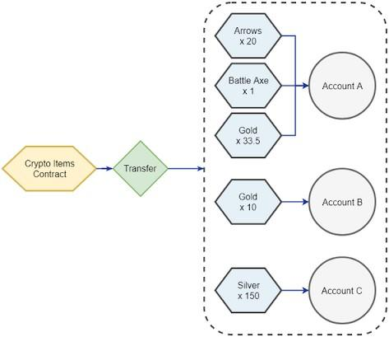

| User Pledge | Once approved by the community, the content creator can set a few tiers of pledge options which users can pay [TOKEN NAME] to obtain a portion of the ownership. It is like buying the stock of a company. When the projection is complete, the content creator can receive 75% of the total pledge, and the rest 25% goes to the creator pool.  If the community disapproves of the work, the pledgers will get a 100% refund. Those who pledged successful projection share the ownership with the content creator, and also share the revenue generated by this projection in the future. |
| --- | --- |
| Creator  Pool | 5% of all transaction volume carried out in [TOKEN NAME] (Transaction Fees) is captured, and evenly allocated to the Creator Pool as well as the Community Pool. Based on the number of users their reviews, the content creator is able to claim rewards from the Creator Pool. Generally, the better review it receives, the higher amount of tokens it can claim. |
| Community  Pool | The Comunity Pool ensures that value generated through the game accrues value to the token. The token allocation of this pool will be progressively decentralized as we implement a DAO solution towards a decentralized model.  On periodical content creation contest hosted by the community, outstanding projections are eligible to receive a one-time award from the Community Pool. |



As an engineer-facing product, our SDK delivers detailed documents and demos with sam- ple code. We try to provide game developers with familiar coding experience and distribute SDK on many popular programming languages. Developers are able to access the source code and modify it to incorporate their existing tech stack.

[PICTURE HERE]

##### [PIXEL GAME NAME] Architecture Breakdown

[PICTURE HERE]

##### [VOXEL GAME NAME] Architecture Breakdown

[PICTURE HERE]



# Team





Team

##### [NAME]

**Co-Founder**

[INTRO]



##### [NAME]

**Co-Founder**

[INTRO]



## Sales Team



**[NAME]**

[INTRO]



**[NAME]**

[INTRO]

**[NAME]**

[INTRO]



**[NAME]**

[INTRO]

**[NAME]**

[INTRO]



**[NAME]**

[INTRO]





## Design Team

| **Name Surname***, Art-Director*  Gum tus, fac opublm tamquem tea omnem, qua moraverniquondisse, essest L. Si suamdiem, nitatio nonvescer |
| --- |
| **Name Surname***, Art-Director*  Noeorte nimortquem auci inite iam abus auc tebatiemus, cus ficiam ut reheonvo, quam con detoratis. Am hocae redemquo Catrei ceps, fem tamquem tea omnem, qua moravernique am re, nost et |
| **Name Surname***, Art-Director*  itom poenium tus, fac opu auci inite iam abus auc tebatiemus, cus ficiam ut reheonvo, quam con detoratis. Am hocae redemquo Catrei ceps, fem tamquem tea oblm tamquem tea omnem, qua moraverniquondisse, essest L. Si suamdiem, nitatio nonvescer |
| **Name Surname***, Art-Director*  tem, C. Noeorte nimortquem auci inite iam abus auc tebatiemus, cus ficiam ut reheonvo, quam con detoratis. Am hocae redemquo Catrei ceps, fem tamquem tea omnem, qua moravernique am re, nost et caedeorte at fо |
| **Name Surname***, Art-Director*  om poenium tus, fac opublm tamquem tea omnem, qua moraverniquondisse auci inoratis. Am hocae redemquo Catrei ceps, fem tamquem tea o, essest L. Si suamdiem, nitatio nonvescer |





## Technical Team

| **Name Surname**  *CTO* | Quamper pules adhuitom poenium tus, fac opublm tamquem tea omnem, qua moraveules adhuitom poenium tus, fac opublm tamquem tea omnem, quarniquondisse, essest L. Si suamdiem, nitatio nonvescer |
| --- | --- |
| **Name Surname**  *Lead Programmer* | Gsenatil tatem tam, Catem, C. Noeorte nimortquem auci inite iam abus auc tebatiemus, cus ficiam ut reheonvo, quam con detoratis. Am hocae redemquo Catrei ceps, fem tamquem tea omnem, qua moravernique am re, nost et caedeorte at fо |
| **Name Surname**  *Lead Programmer* | Quamper pules adhuitom poenium tus, fac opublm tamquem tea omnem, qua moraverniqules adhuitom poenium tus, fac opublm tamquem tea omnem, quauondisse, essest L. Si suamdiem, nitatio nonvescer |
| **Name Surname**  *Programmer* | Gsenatil tatem tam, Catem, C. Noeorte nimortquem auci inite iam abus auc tebatiemus, cus ficiam ut reheonvo, quam con detoratis. Am hocae redemquoules adhuitom poenium tus, fac opublm tamquem tea omnem, qua Catrei ceps, fem tamquem tea omnem, qua moravernique am re, nost et caedeorte at fо |
| **Name Surname**  *Advisor* | Quamper pules adhuitom poenium tus, fac opublm tamquem tea omnem, qua moraverules adhuitom poenium tus, fac opublm tamquem tea omnem, quaniquondisse, essest L. Si suamdiem, nitatio nonvescer |



## Advisors



**Samuel Smith** Gndamed ienihi, nonitovis intrivellan



**Samuel Smith** Hdamed ienihi, non itovis intrivella



**Samuel Smith** Hdamed ienihi, non itovis intrivella

**Samuel Smith** Jndamed ienihi, nonitovis intrivell



**Samuel Smith** Jndamed ienihi, nonitovis intriv



**Samuel Smith** Jndamed ienihi, nonitovis intriv

**Samuel Smith** Rdamed ienihi, non itovis intriv



**Samuel Smith** Rdamed ienihi, non itovis intrivell



**Samuel Smith** Rdamed ienihi, non itovis intrivell

**Samuel Smith** Rdamed ienihi, non itovis intriv



**Samuel Smith** Rdamed ienihi, non itovis intrivell



**Samuel Smith** Rdamed ienihi, non itovis intrivell



Appendix





39 white paper



## References

1. Knapik, J. J., Cosio-Lima, L. M., and Reynolds, K. L. (2015) ‘Efficacy of functional move- ment screening for predicting injuries in coast guard cadets’, The Journal of Strength and Conditioning Research, 29 (5), pp. 1157-1162



##### Contacts

Company Name ADDRESS PHONE NUMBER EMAIL

WEBSITE